E – Verificación de Condiciones de Desbloqueo del Monedero
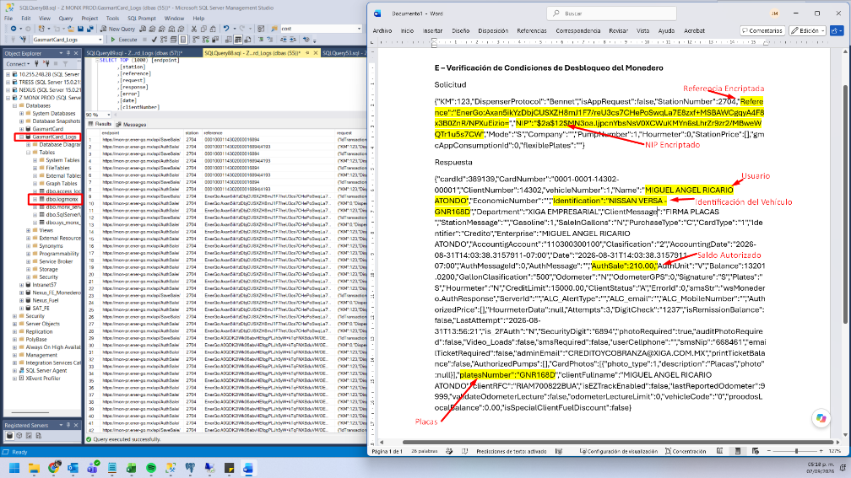
Solicitud
{"KM":123,"DispenserProtocol":"Bennet","isAppRequest":false,"StationNumber":2704,"Reference":"EnerGo:Axan5ikYzDbjCUSXZH8mJ1F7/reU3cs7CHePoSwqLa7E8zxf+MSBAWCgqyA4F8x3B0ZnR/NPXuEizio=","NIP":"$2a$12$MN3oa.ljpcnYbsNsV0XCWuKMYn6sLhrZr9zr2/MBweWQTr1u5s7CW","Mode":"S","Company":"","PumpNumber":1,"Hourmeter":0,"StationPrice":[],"gmcAppConsumptionId":0,"flexiblePlates":""}
Respuesta
{"cardId":389139,"CardNumber":"0001-0001-14302-00001","ClientNumber":14302,"vehicleNumber":1,"Name":"MIGUEL ANGEL RICARIO ATONDO","EconomicNumber":"","Identification":"NISSAN VERSA -GNR168D","Department":"XIGA EMPRESARIAL","ClientMessage":"FIRMA PLACAS ","StationMessage":"","Gasoline":1,"SaleInGallons":"N","PurchaseType":"C","CardType":"1","Identifier":"Credito","Enterprise":"MIGUEL ANGEL RICARIO ATONDO","AccountigAccount":"110300300100","Clasification":"2","AccountingDate":"2026-08-31T14:03:38.3157911-07:00","Date":"2026-08-31T14:03:38.3157911-07:00","AuthMessageId":0,"AuthMessage":"","AuthSale":210.00,"AuthUnit":"V","Balance":13201.0200,"GallonClasification":"500","Odometer":"N","OdometerGPS":0,"Signature":"S","Plates":"S","Hourmeter":"N","CreditLimit":15000.00,"ClientStatus":"A","ErrorId":0,"smsStr":"wsMonedero.AuthResponse","ServerId":"","ALC_AlertType":"","ALC_email":"","ALC_MobileNumber":"","AuthorizedPrice":[],"HourmeterData":null,"Attempts":3,"DigitCheck":"1237","isRemissionBalance":false,"LastAttempt":"2026-08-31T13:56:21","is_2FAuth":"N","SecurityDigit":"6894","photoRequired":true,"auditPhotoRequired":false,"Video_Loads":false,"smsRequired":false,"userCellphone":"","smsNip":"668461","emailTicketRequired":false,"adminEmail":"CREDITOYCOBRANZA@XIGA.COM.MX","printTicketBalance":false,"AuthorizedPumps":[],"CardPhotos":[{"photo_type":1,"description":"Placas","photo":null}],"platesNumber":"GNR168D","clientFullname":"MIGUEL ANGEL RICARIO ATONDO","clientRFC":"RIAM700822BUA","isEZTrackEnabled":false,"lastReportedOdometer":9999,"validateOdometerLecture":false,"odometerLectureLimit":0,"vehicleCode":"0","proodosLocalBalance":0.00,"isSpecialClientFuelDiscount":false}

